Serverless Computing:

Azure Serverless computing helps developers to build powerful applications by eliminating the need to provision and manage infrastructure. In Serverless computing, cloud vendors provision, manage and scale the infrastructure as per the need.

Benefits of serverless computing:

* Increase developer velocity.
* Boost team performance.
* Improve organizational impact.
* Cost benefits.
* Serverless computing enables developers to build applications faster by eliminating the need for them to manage infrastructure.
* Azure serverless architecture.

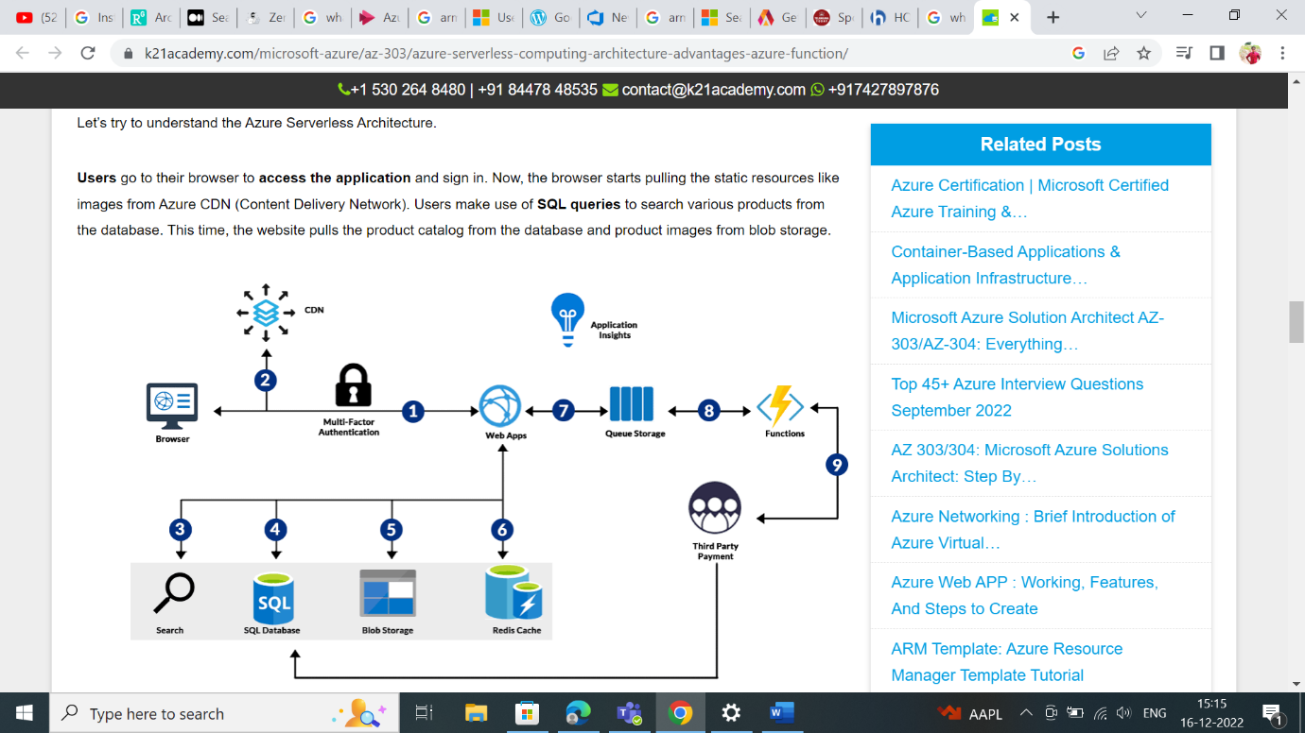

* Network traffic management:
* Network Traffic Management uses network monitoring tools.
* Management techniques such as bandwidth monitoring, deep packet inspection, and application-based routing to ensure optimal network operation.
* Network Traffic Management is used alongside other optimization techniques like Application Traffic Management as part of an overall Application Delivery Network solution.